# January 29, 2013

# The Roles of K+ Currents in Human Articular Chondrocyte Electrophysiology:

# A Computational Perspective

**Harish Narayanan\***  
*Center for Biomedical Computing,*   
Simula Research Laboratory, Lysaker, Norway

**Mary M. Maleckar,**   
*Center for Biomedical Computing,*   
Simula Research Laboratory, Lysaker, Norway

**Robert B. Clark,**   
*Faculty of Kinesiology,*   
University of Calgary, Calgary, Canada

**James R. Wilson**

**Wayne R. Giles,**   
*Faculty of Kinesiology,*   
University of Calgary, Calgary, Canada

*Corresponding author. Address: Center for Biomedical Computing, Simula Research Laboratory, P.O. Box 134, 1325 Lysaker, Norway Tel.:+47 4003-4801, Fax: +47 6782-8201

### Abstract:

We have developed a computational model for studying the electrophysiology of the human chondrocyte. This model is based on an initial experimental data set which identified the main K+ currents expressed in single cells isolated from knee joints of healthy adult human donors. The applicability and utility of this model are illustrated by focusing on the role of a novel 2-pore K+ current in regulating the chondrocyte resting potential and modulating intracellular Ca2+ homeostasis. This model is demonstrated to be useful for integrating available data from electrophysiological, PCR and gene array experiments. It is also an important adjunct for rationalization of working hypotheses, design of new experiments and understanding the principles and limitations of patch clamp methods as applied to the isolated human chondrocyte.

*Key words:* chondrocyte; electrophysiology; potassium currents; computational model

# 

**INTRODUCTION**

Articular cartilage is considered to be an aneural, avascular, alymphatic component of the flexible connective tissue that covers the articulating ends of diarthroidal joints (1-3). It is essential for the required stability and low friction movement of the associated long bones. This connective tissue consists of an extracellular matrix (ECM, composed primarily of collagen, elastin and proteoglycans, (as detailed below) and only one type of cell - the chondrocyte. Articular cartilage is exposed to cyclical mechanical forces; in fact, this dynamic environment is essential for the health of the tissue (2). Chondrocytes occupy only approximately 1-10% of the total volume of articular cartilage in mammals ([4](chondrocyte-model.html#CarneyMuir1988),[5](chondrocyte-model.html#Halletal1996)) and play no direct mechanical role. Instead, chondrocytes are responsible for synthesis and homeostasis of the extracellular matrix. Mechanical support is provided by the ECM, which is composed of (a) collagen fibers that give the tissue the ability to resist tension, (b) negatively-charged gel-like proteoglycans (PGs) that are trapped within the collagen mesh and allow the tissue to bear compression (1,8) and (c) synovial fluid within the articular capsule which acts as a lubricant, thus ensuring low friction movement of the bones (7). The primary role of the human chondrocyte is to maintain viable cartilage by balancing macromolecular synthesis and breakdown (see e.g. 2,7,9).

In a variety of conditions (including healthy aging), or as a consequence of injury, progressive chondrocyte damage and dysfunction may occur (10-12). As a result, the balance between matrix synthesis and degradation is altered and the low friction environment of the joint may be reduced or lost (9). Under these conditions, there is often an inflammatory response within the articular joint. This is one factor that increases the early development of osteoarthritis: a thinning of the cartilage layer which causes painful, bone-against-bone friction (1,11). The progression of osteoarthritis (12,13) and the ability of chondrocytes to respond to perturbations in the extracellular environment (14) are associated with deficiencies in chondrocyte volume regulation (15). It is known that physical damage to cartilage is more frequent in the setting of altered osmolarity (16). In turn, there is evidence that these volume changes are linked to an abnormal resting potential in chondrocytes (17), which may be due to changes in K+ and/or Cl- channel activity. However, direct experimental investigations that address possible functional relationships between chondrocyte electrophysiology and pathophysiology are challenging due to the small cell size of the mature chondrocyte and the associated limitations of *in vitro* electrophysiological studies. In fact, it is not at all certain that conventional patch pipette methods (18,19) can accurately determine the resting potential of isolated single chondrocytes (20). Accordingly, for the purpose of integrating available experimental data and attempting to understand its functional significance, we have developed a detailed biophysical model of human chondrocyte electrophysiology. This model can facilitate investigation of electrophysiological mechanisms, which regulate chondrocyte physiology and pathophysiology and are the targets of intra- and intercellular signaling pathways responsible for biomechanical roles, including excitation-secretion coupling.

The main goals of this work are (i) to develop the first detailed mathematical model of chondrocyte electrophysiology and (ii) to illustrate the utility of the model in investigating the dependence of the chondrocyte resting membrane potential, and by extension the volume and signaling regimes of the chondrocyte, on key voltage- and ligand-gated membrane channels.

**MODEL DEVELOPMENT AND METHODS**

The chondrocyte cell membrane is known to express a number of voltage- and ligand-gated ion channels as well as pumps and exchangers (30). Patch clamp experiments performed on enzymatically isolated individual human chondrocytes obtained with permission from a knee replacement surgery program (The Southern Alberta Transplant Service) provide the experimental basis for this model development. These chondrocytes evinced resting membrane potentials ranging from -30 to -60 mV when superfused with normal Tyrodes solution and studied using antibiotic-permeablized (amphotericin) patch clamp methods (28). This significant range of resting membrane potential values may reflect the heterogeneous physiological state of these cells. However, as we have illustrated previously, some of this variability is likely to result from the fact that in these very small, approximately spherical cells (diameter, 7 microns; capacitance 10-15 pF) the patch pipette recording method is being applied very near its technical limitations (20). That is, the input resistance of the target cell (chondrocyte) is very large (1-10 gigohms), and the seal resistance between the surface membrane of the chondrocytes and the polished surface of the glass pipette has a typical value of 1-5 gigohms. Thus, the actual chondrocyte membrane potential may be underestimated due to the current flow through the seal resistance, which in most circumstances results in an apparent depolarization. The Appendix of this manuscript describes the known biophysical principles which, when combined, regulate the ways in which the combination of patch pipette seal resistance and intrinsic input resistance result in apparent values for the resting potential in small cells such as the human chondrocyte.

The main objective of this first model is to obtain insights into the ionic mechanisms that underlie the resting potential in the human chondrocyte *in situ*. The raw data that forms the basis of this model is derived mainly from our previously published recordings of the K+ currents in human (28), mouse (31) and canine chondrocytes (32). Other elements summarized diagrammatically in Figure 1 below are obtained from published literature on isolated chondrocytes from rabbit, canine and equine tissue.

[Figure 1 near here]

## The Atypical Environment of the Chondrocyte

The chondrocyte is situated in a physiological environment that differs significantly from that of most other mammalian cells (as summarized in Table 1). Despite this unique extracellular environs, the large electrochemical gradients for Na+, K+ and Cl- across the cell membraneare very similar to those in other mammalian tissue types. These gradients lead to the requirement for an ATP-dependent Na+/K+ pump mechanism, assumed to be electrogenic, in order to maintain ionic homeostasis. Note, however, that the extracellular fluid within the articular joint is hypertonic (approximately 320 mOsm vs. blood plasma which is approximately 280 mOsm). In addition, the extracellular pH of the synovial fluid that bathes the chondrocyte is somewhat acidic, pH 7.2 (8,24) although apparently an intra- to extracellular pH gradient also typical for other cell types can be identified (references?).

The substantial number of fixed negative charges on proteoglycans immediately adjacent to the chondrocyte can attract free cations (e.g. Na+) and exclude free anions from the matrix. As a result of this cation accumulation (Table 1), there is an osmotically driven water influx to the cell. (10,17).

The articular joint receives little or no vascular supply. As a result, the synovial fluid must supply adult articular cartilage with the required small amounts of nutrients as well as oxygen to e.g., maintain Na+/K+ pump activity (33). Metabolic byproducts are removed mainly by diffusion (34,35). A second consequence of the avascular nature of this tissue is that chondrocytes generate ATP by substrate-level phosphorylation during anaerobic respiration. This generates H+ ions as a byproduct, which further lowers the pH in this micro environment. The dynamic changes in mechanical loading within the knee joint during activity also exposes chondrocytes to very significant fluctuations in vector forces and shear. The resulting mechanical changes would be expected to activate mechano- or shear-sensitive ion channels (36-40).

Experimentally-reported values for the external cation concentrations differ markedly from those of extracellular fluid in other mammalian tissues. We have also incorporated these atypical values for extracellular ion concentrations (Table 1).

**Table 1:** Consensus Values of Ion Concentrations for Chondrocyte Electrophysiology, given in millimolars (mM) ([8](chondrocyte-model.html#Wilkinsetal2000)).

|  |  |  |  |  |  |  |  |  |  |  |  |  |  |  |  |  |  |  |  |  |  |  |  |  |  |  |  |  |  |  |  |  |  |  |  |  |  |  |  |  |  |  |  |  |  |
| --- | --- | --- | --- | --- | --- | --- | --- | --- | --- | --- | --- | --- | --- | --- | --- | --- | --- | --- | --- | --- | --- | --- | --- | --- | --- | --- | --- | --- | --- | --- | --- | --- | --- | --- | --- | --- | --- | --- | --- | --- | --- | --- | --- | --- | --- |
| |  |  |  |  |  | | --- | --- | --- | --- | --- | |  | Cytoplasm | Matrix | Serum/Synovium |  | | [Na+]o (mM) | 40 | 240-350 | 140 |  | | [K+]o (mM) | 120-140 | 7-12 | 5 |  | | [Ca2+]o (mM) | 8.e-5 | 6-15 | 1.5 |  | | [Cl-]o (mM) | 60-90 | 60-100 | 140 |  | | [HCO3-]o (mM) | 20 | 15 | 23 |  | | [SO42-]o (mM) | 0.17 | 0.30 | 0.81 |  | | pH (mM) | 7.1 | 6.6-6.9 | 7.4 |  | | Osmolarity (mOsm) | -- | 350-450 | 300 |  | |

**Membrane Currents**

### *Background Currents*

The model accounts for leakage of Na+ and K+ through time-independent, non-specific cation channels using standard Hodgkin-Huxley formalism:

|  |  |
| --- | --- |
|  | (1)  (2) |

Where XX is XX...

And the Nernst potentials for Na+ and K+ are computed based on their respective intra- and extracellular concentrations:

|  |  |
| --- | --- |
| Where XX is XX... | (3)  (4) |

In a variety of mammalian chondrocyte preparations, one or more types of Cl- conductance have been identified (59,c.f. 30). This quasi-linear Cl- conductance has also been identified in human chondrocyte cell lines (61), and in experiments in which selected transmitters or pharmacological agonists (e.g., histamine) have been applied (62). We have incorporated this type of current into our model by treating it as a background current, specified by the equations below.

|  |  |
| --- | --- |
|  | (5) |

Where XX is XX...

and

|  |  |
| --- | --- |
|  | (6) |

is the Nernst potential due to the difference in Cl- concentration inside and outside the cell. Where XX is XX...

The current-voltage (IV) relationships for these sodium, potassium, and chloride background currents (INab, IKb, and IClb, respectively) are shown in Figure 2A.

### *Ion Pumps and Exchangers*

**(a) Na+/K+ Pump**

The active extrusion of Na+ ions from the chondrocyte is assumed to be achieved by the turnover of an electrogenic Na+/K+-ATPase. Mobasheri et al (33) have characterized some of the functional properties of an electrogenic Na+/K+ pump in bovine articular chondrocytes. Cell volume is maintained by altered balance of leaks and pumps to hold cell water constant. In this model, we employ the following sodium-potassium pump formulation (42).

|  |  |
| --- | --- |
|  | (7) |

Where XX is XX...

**(b) Na+ /Ca2+ Exchanger**

As in many other cell types, the Na+/Ca2+ exchanger plays a key role in Ca2+ homeostasis in articular chondrocytes (41). We model this electrogenic exchange process using the following mathematical expression (42).

|  |  |
| --- | --- |
|  | (8) |

Where XX is XX...

**(c) Na+ /H+ Exchanger**

Chondrocytes express a Na+/H+ antiporter (43,44), which allows the cell to regulate pH and establish an intra- to extracellular pH gradient. This pH gradient is essential for maintaining intracellular Na+ levels and the intracellular pH indirectly regulates a number of essential enzymatic processes. In order to model this channel, we use the following functional form (45):

|  |  |
| --- | --- |
|  | (9) |

where,

|  |  |
| --- | --- |
|  |  |

### Figure 2B shows I-V curve for these electrogenic pump and exchangers INaK, INaCa, and INaH.

1. Where XX is XX...

### *Potassium Currents*

This model also incorporates mathematical expressions for a total of four distinct K+ currents identified from electrophysiological studies performed on mammalian chondrocytes. Two of these, a delayed rectifier K+ current, which we denote IK-DR, and a K+ current due to a 2-pore K+ channel, which we denote IK-2P, have been studied in detail in our laboratory (28,32) and by others (45-57). The remaining two K+ currents, a Ca2+-activated K+ current (IK-Ca) and an ATP-dependent K+ current (IK-ATP) have been identified in other patch clamp studies. These are also included.

**(a) Delayed Rectifier K+ Current: IK-DR**

A time- and voltage-sensitive K+ current has been identified in the human articular chondrocyte (28-32). The biophysical properties of this current and the details of its pharmacological blockade suggest that it is generated by the family of alpha subunit K+ conductances denoted Kv1.4 or Kv1.6. Accordingly, IK-DR is modeled by the following:

in our model.

Where XX is XX...

In the above equation, aur is time-dependent channel activation, and is defined by the following expression:

|  |  |
| --- | --- |
|  |  |

Where XX is XX...

Panel A of Figure 3 shows an experimental I-V relationship generated under physiological conditions, that is, a normal electrochemical gradient for K+, with the corresponding model results. Figure 3B shows steady-state activation, and Figure 3C illustrates the kinetics of activation and inactivation.

[Figure 3 near here]

**(b) 2-Pore K+ Current:**

Our recent work has identified recording conditions under which an additional K+ current, generated by what is believed to be the TASK family of 2-pore K+ channels (28), is measured. These channels show no detectable time dependence. An additional characteristic of this subclass of 2-pore channels is their significant increase in conductance in response to an increase in pH or alkalinization of the extracellular medium. A peak I-V curve for this current is shown in Panel A of Figure 4, while Figure 4B illustrates the enhancement of this current when extracellular pH was changed from XX.

These recordings were performed under conditions of elevated extracellular K+, so that the size of the currents could be increased to a detectable level wherein biophysical properties could be resolved. Before this data could be appropriately modeled and incorporated, it needed to be corrected to physiological conditions. The correction employed is based on the Eisenman principle (54): the conductance of an ion-selective channel scales according to the square root of the extraconcentration of that permeant ion. The I-V curve in Figure 4C shows the original data recorded in isotonic K+ (~145 mM), with the expected reversal potential of 0 mV, together with the corrected data (assuming external K+ to be 5.4 mM with a corresponding reversal potential of approximately -85 mV).

[Figure 4 near here]

Using the classic Goldman-Hodgkin-Katz equation (54) for voltage-gated, time-independent single-species ion channels, this current can be represented by:

|  |  |
| --- | --- |
|  | (11) |
| Where XX is XX... |  |

Figure 5 shows the current-voltage curve as fitted to experimental data (28) obtained in isotonic conditions (panel A), and when corrected for an assumed normal extracellular potassium concentration of 5.4 mM (panel B). Experimental work also demonstrated that this particular K+ current was strongly inhibited by bupivacaine; an effective concentration of bupivacaine also resulted in a significant depolarization of the resting potential (see Discussion).

[Figure 5 near here]

**(c) Ca2+-Activated K+ ­(BK) Current**

Virtually all recordings of global K+ currents in human chondrocytes include a significant and very noisy outward current at depolarized potentials (55,56). The spontaneous fluctuations of this current suggest that it is generated by the so-called large conductance (BK) variant of the Ca2+ activated K+ current family (57). We have not explored the biophysical properties of this current or its pharmacological profile in any detail. However, it is consistently present in our recordings and a Ca2+-activated K+ current has also been described in isolated chondrocytes from rabbits, dogs and horses (47), and is thus included in the current model.

For the given data set (34), the (large) Ca2+-activated K+ channel can be represented by (57,58):

|  |  |
| --- | --- |
|  | (12) |

where,

|  |  |
| --- | --- |
|  |  |

Where XX is XX...

Figure 6 shows the current-voltage relationship for this current as fit to recent experimental data.

[Figure 6 near here]

**d) ATP-sensitive K+ Current**

An ATP-sensitive K+ current has been reported in chondrocytes from a variety of mammalian species (59). Our previous experimental work in human articular chondrocytes (34) did not address this possibility and there are no reports of this current being activated in human chondrocytes in the literature. However, the hypoxic environment of the articular chondrocyte makes the presence and the activation of this current during normal biomechanical activity plausible, and thus this current is include in the present model, as shown in Figure 7:

I_K_ATP = sigma*g_0*p_0*f_ATP*(V - E_K) (15)

Where XX is XX...

[Figure 7 near here]

***Other Sarcolemmal Currents***

**b) Transient Receptor Potential or TRP Current**

Ligand gated channels that exhibit properties that correspond to some of those of TRP ion channels are expressed in mammalian chondrocytes (63). The TRPV4 family is prominently expressed in mouse chondrocytes (64,65). For that reason this type of ion channel has been incorporated into this initial model of the human chondrocyte (Figure 8). The rationale for doing this is based on the likelihood that this type of conductance is needed to explain electrophysiological responses to naturally occurring paracrine substances (e.g., ATP) or to cytokines that are liberated in the setting of acute or chronic inflammation (e.g., XX). A further reason for incorporating this type of conductance into this early model is that this type of ion channel exhibits significant permeability to both Na+ and Ca2+ (68). Either or both of these cation species are likely to be important in regulating excitation secretion coupling and could modulate cell volume. It is also known that this type of ion channel can couple to purinergic receptors and/or to specific connexin proteins which function in the context of intercellular electrotonic communication, or as hemi-channels (see below).

[Figure 8 near here]

|  |  |
| --- | --- |
|  | (13) |

Where XX is XX...

***Intracellular Ca2+ Homeostasis***

The chondrocyte’s intracellular Ca2+, [Ca2+]i, is maintained by the sodium calcium exchanger (eq. 8), a sarcolemmal electroneutral Ca2+ ATP-ase (eq. 12) and via intracellular buffering (eq. 13 and 14). In the absence of more concrete data, the intracellular Ca2+ buffering in the present model is attributed mainly to calmodulin within the cytosol and is represented as in our previous models of the atrial myocyte (42,48).

I_Ca_ATP = I_Ca_ATP_bar*(Ca_i/(Ca_i + k_Ca_ATP)) (12)

dO_c/dt = 200,000*Ca_i*(1.0 – O_c) - 476.0*O_c (13)

dCa_i/dt = (I_NaCa - I_Ca_ATP)/(vol_i*F) - 0.045* dO_c/dt (14)

Where XX is XX...

## Implementation and Utilization of this Model

All individual transmembrane ionic currents above are defined by Equations 2-12. The ODE system (68) is solved for the primary vector of unknowns: Vm, [Na+]i , [K+]i , [Ca2+]i , [H+]i , [Cl-]i , aur and iur. All initial conditions were chosen from previous calculations that were run to steady state. This equation system is solved using LSODE (68). The corresponding GNU Octave code is available free and open source.

In this first order model we do not account for spatial variations in quantities of interest. As a result the human chondrocyte can be modeled by the following set of ordinary differential equations (ODEs) in time.

|  |  |
| --- | --- |
|  | (14) |

Where XX is XX...

where,

|  |  |
| --- | --- |
|  |  |

Where XX is XX...

***Connexin Mediated Current Flow***

The chondrocyte from adult humans functions as an isolated cell. As a result it may seem that consideration of connexin function is irrelevant. However data from humans during early adolescence suggest that the growth plate of articular joints is characterized by small groups of directly opposed chondrocytes with expression of selected members of the connexin family being detectable using standard immunohistochemical approaches (66). Moreover it is now known that even in the case of adult isolated cells prominent ATP release can be observed (67). One plausible mechanism for this chemical or mechanical release is transient opening of HEMI channels due to expression of either pannexin or connexin subunits. For these reasons our model incorporates a connexin mediated conductance which, however, under physiological conditions is shut off or has a value of 0 pS.

**RESULTS**

## Model Characteristics

Experimental conditions described in [Clark et al. (13)](chondrocyte-model.html#Clarketal2011) were first replicated in the simulations to fit significant potassium currents used in the model. For this, the exterior concentrations of the various species in the model were set to experimental values ( [K+]o = 5 mM, [Na+]o = 140 mM, [Ca2+]o = 2 mM, pH = 7.4 for IK, Ca2+-act and IKur ) and ( [K+]o = 5 mM, [Na+]o = 145 mM, [Ca2+]o = 2 mM, pH = 8.5 for IK2pore ), and the potential was linearly ramped over 1 s from -130 mV to +100 mV. The evolution of the concentrations and currents were tracked in this period, and multiple simulations of this nature were used to fit parameters for IK2 pore, IK, Ca2+-act and IKur). Figure 2 shows these individual currents and their fit to experimental values from [Clark et al. (13)](chondrocyte-model.html#Clarketal2011). The other currents used in the model are significantly smaller in magnitude, and have not been specifically fit due to lack of experimental data. (Figure 3)

After this primary parameteristion, the overall model behaviour was studied under a linear voltage ramp from -130 mV to +90 mV under conditions matching experiments ([K+]o = 5 mM, [Na+]o = 140 mM, [Ca2+]o = 2 mM, pH = 7.4) to reveal that the overall voltage-current behaviour of the chondrocyte model reproduces the experimental data quite closely ([13](chondrocyte-model.html#Clarketal2011)). This comparison is shown in Figure 4 along with corresponding time evolution of the total current in the model.

The initial conditions used in the simulations were steady state values of the solution under same conditions used for the different numerical experiments. Figure 5 shows that, when starting from a steady state solution, the concentrations in the model do not evolve over a relatively long simulation period of 30 min. The initial conditions for the concentrations used in the computations were [Na+]i = 2.814 mM, [K+]i = 121.59 mM, [Ca2+]i = 2.371e-06 mM, [H+]i = 6.188e-10 mM, [Cl-]i = 13.209 mM. When the model is perturbed from these conditions, it returns to steady state values in a similar time frame.

Model development has proceeded in defined stages starting with implementation of the minimal requirements for generation of a resting potential.

i) Background Currents

Output from our initial simulations is shown in the current voltage (I-V) relationship in Figure 2. This I-V curve illustrates what are termed 'background currents'. In this model these include the resting Na+, K+, and Cl- fluxes. Also shown is the small outward current that is generated by the electrogenic Na+/K+ pump that has been scaled to achieve a steady-state intracellular Na+ concentration of 10-12 mM. The remaining background currents, shown in Figure 2B, are those that are generated by the Na+/Ca2+ exchanger under resting and steady-state conditions corresponding to an intracellular Na+ concentration of 12 mM, and assumed free intracellular Ca2+ concentration of 3 x 10-8 M. In the mammalian chondrocyte there is also evidence for a background flux of Na+ and H+. Equations which capture this electroneutral ion transfer are included since it is anticipated that pH regulation and regulation of intracellular Na+ levels are of importance in both physiological and pathophysiological settings.

The scaling of current densities is dictated by the known input resistance of the cell, which is approximately 2 Gigohms. This value is denoted on the I-V curve by the thickened trace in the region of the range of resting membrane potentials that has been reported.

DISCUSSION:

i) Practical Applications of this Model

In the present state of its development, our model represents an original but only semiquantitative tool that can be used as one part of our multidisciplinary studies of electrophysiological and biophysical principles of the human chondrocyte. Our initial emphasis was on investigating the basis of the resting potential (Em) since our data set consists mainly of K+ current measurements in this non-excitable cell. Moreover, it is known that even very small changes in the resting membrane potential can strongly modulate factors that govern intracellular Ca2+ signaling and homeostatic mechanisms. There is also evidence that relatively small alterations in membrane potential contribute to dynamic regulation of cell volume. Both the strength and duration of ligand gated conductance changes are dependent upon membrane potential (Em) since this sets the electrochemical driving force.

The computations shown in Figures XX through XX in fact do not fully explain the ionic basis for the resting membrane potential in the human chondrocyte. Rather, they serve to illustrate that a range of membrane potential values is to be expected. This is because the net outward current that sets the resting membrane potential is very small even though it is the algebraic sum of background conductances as well as currents due to the electrogenic Na+/K+ pump and Na+/Ca2+ exchanger. In many recording situations the leak current through the patch pipette seal resistance can influence (and could even dominate) the observed 'resting potential'. In addition spontaneous changes in this seal resistance can give the impression of an unstable resting potential in these cells.

Nevertheless, our computational work does provide a basis for addressing the question, 'what are the physiological roles of each of the four K+ currents that have been identified and characterized in human chondrocytes'? At the outset one can appreciate from the computed I-V curves that any, or all of these currents could: i) significantly hyperpolarize the resting potential or ii) repolarize the chondrocyte after it had been depolarized by e.g., the effects of mechanical activity or by a ligand gated conductance.

An example of this, illustrated in Figure XX, is based on simulation of the electrophysiological response observed following activation of the TRP channels that are known to be expressed in human chondrocytes. A characteristic TRPV4 I-V curve is shown in Figure XX. The effect of this channel mediated current on the resting membrane potential can be deduced by adding this current to the steady-state I-V relation illustrated in Figure XX. The resulting net current is shown in Figure XX. From this it is clear that activation of TRP channels results in a transient depolarization of the chondrocyte. However and possibly more importantly, it is also apparent that TRP channel activation results in a significant influx of Ca2+ and Na+ under circumstances in which the chondrocyte membrane potential is negative to approximately -40 mV. The TRP channel induced depolarization is limited in magnitude and eventually transformed into a repolarization by the voltage dependent activation of the delayed rectifier K+ current, IK-DR. It follows that under circumstances in which the TRP channel results in a significant increase in intracellular Ca2+, the Ca2+ dependent K+ current, IK-Ca will also be activated. This will hyperpolarize the membrane potential and this potential will be maintained until intracellular Ca2+ and/or Ca2+ dependent signaling mechanisms reset to resting values.

[Figure 9 near here]

Consideration of the physiologic milieu within the articular joint identifies conditions under which some of these K+ currents may be modulated significantly. For example, the extracellular fluid is hypertonic. The effects of osmolarity on voltage gated K+ currents have been studied extensively. In brief, as a consequence of changes in surface charge shielding alterations in superfusate tonicity can significantly shift the steady state gating of currents such as IK-DR. Our experimental work is done under fixed isotonic conditions. The literature would suggest that an increase in osmotic strength would cause a shift to the right, in the depolarizing direction by perhaps 5 mV. This biophysical correction would make it unlikely that IK-DR makes any significant contribution to the resting potential. However, this alteration would position this current to initiate prompt repolarization following any transient depolarization, while also ensuring that the input resistance of the cell at the resting potential remained very high. This is a critical factor since a minimum of ion transfer is desirable in the relatively hypoxic milieu of the articular joint.

Bup:

Early signs of osteoarthritis may develop even in young individuals following articular joint injury. This is thought to be due to a phenomenon denoted 'chondrolysis', a condition in which accelerated loss of articular cartilage occurs over a short time period (21-23). Several clinical studies have also documented that this significant pathophysiological response can occur as a result of postoperative administration of bupivacaine, a local anesthetic. Experimental work has confirmed that bupivacaine can cause profound effects including chondrocyte death in both isolated cell experiments (24) and associated animal studies (25-28). However, the cellular and subcellular mechanisms responsible for this toxic response (characterized by increased apoptosis) are not completely understood. In this regard, it is interesting to note that a family of two-pore K+ channels that have been recently identified in human articular chondrocytes can be inhibited by bupivacaine (29). Since bupivacaine-induced block of these and other (29) 2-pore K+ channels can result in a pronounced depolarization of the chondrocyte it is important to gain a detailed understanding of the functional relationships between membrane potential, intracellular Ca2+ levels (that can regulate apoptosis) and cell volume which can modulate excitation-secretion coupling.

ii) Limitations of this Model

As presented, this mathematical model of chondrocyte electrophysiology provides a reliable platform for explaining and evaluating the experimental data in this field. This first order model also has proven utility for rationalizing and integrating genomic data from expression array profiles and as part of ion channel/antiporter drug target initiatives. Iterations based on the semiquantitative approach that is made possible by this model can also be useful for designing new experiments that are aimed at revealing cellular mechanisms that govern/modulate excitation-secretion coupling. Finally, given that the chondrocyte is in a unique, but yet not completely defined microenvironment our model provides a basis for explaining: i) the known biophysical effects of alterations in ionic strength of synovial fluid on ion channel voltage-dependent gating (zeta potential effects), ii) one common approach in attempts to account for the effects of cyclic stretch on ion channels - strain dependent alterations in channel gating voltage dependence or kinetics (cf. YYYY), and iii) much needed approaches for detecting and determining the limitations of present patch clamp technology that can bias, if not dictate, resulting data sets and influence their interpretation.

We recognize that at this stage our model has significant limitations. These include but are not limited to:

a) The absence of any comprehensive account or set of mathematical descriptors for intercellular Ca2+ homeostasis. Extension of the model to include simulations of the Ca2+ is needed before it can be used to explore the roles of Ca2+-activated K+ and/or Cl- currents.

b) Essential aspects of excitation-contraction coupling including the sources for the Ca2+ which triggers and supports secretion and the reuptake or extrusion mechanisms for this Ca2+.

c) Mathematical expressions that would allow rationalization of what has been termed 'the AM and FM modes of Ca2+ signaling' which will require consideration of intracellular Ca2+-dependent phosphorylation and dephosphorylation reactions and consideration of the Ca2+-dependence involved in transcriptional regulation of ion channel, antiporter and pump target molecules.

d) An improved understanding of and development of mathematical approaches that may account for the response of the chondrocyte to the ambient hypoxia within the articular joint. Initially this is likely to require formulation of equations for hypoxia-activated K+ channels.

e) Adaptation of published mathematical formulations for alteration of ion channel activity arising from cyclic biomechanical stretch or from transient changes in shear forces that impinge upon the chondrocyte.

ACKNOWLEDGEMENTS:

An Alberta Innovates - Health Solutions Scientist Award (WRG), an AI-HS Starter Grant, and Canadian Institutes of Health Research, supports experimental work in the Giles laboratory for operating funds. We are grateful to the Southern Alberta Tissue Transplant Facility (Dr. R. Krawetz) for supply of human articular joint (knee) tissue. Ms. Colleen Kondo prepared the human chondrocyte cultures and was responsible for project management. Postdoctoral fellowship funding from Simula Research Laboratory, Oslo, Norway and the AI-HS is gratefully acknowledged.

CONFLICT OF INTEREST:

None of the authors have any conflict of interest items to declare.

# 

## References

1 Poole, C. A. 1997. Articular cartilage chondrons: form, function and failure. *J. Anat.* 191:1-13.

2 Muir, H. 1995. The chondrocyte, architect of cartilage. Biomechanics, structure, function and molecular biology of cartilage matrix macromolecules. *Bioessays* 17:1039-1048.

3 Huber M., S. Trattnig and F. lintner. 2000. Anatomy, biochemistry and physiology of articular cartilage. *Invest. Radiol,* 35:573-580.

4 Stockwell, R. A. 1991. Cartilage failure in osteoarthritis: Relevance of normal structure and function. A Review. *Clin. Anat.* 4:161-191.

5 Hall, A. C., E. R. Horwitz, and R. J. Wilkins, 1996. The cellular physiology of articular cartilage. *Exp. Physiol.* 81:535-545.

6 Carney, S. L., and H. Muir, 1988. The structure and function of cartilage proteoglycans.   
*Physiol. Rev.* 68:858-910.

7 Buckwalter, J. A., and H. J. Mankin, 1998. Articular cartilage: Tissue design and chondrocyte-matrix interactions. *Instr. Course Lect.* 47:477-486.

8 Edwards, J. C., L. S. Wilkinson, … A. A. Pitsillides, 1994. The formation of human synovial joint cavities: A possible role for hyaluronan and CD44 in altered interzone cohesion. *J. Anat.* 185:355-367.

9 Urban J.P., A.C. Hall and K.A. Gehl, 1993. Regulation of matrix synthesis rates by the ionic and osmotic environment of articular chondrycytes. *J. Cell. Physiol.* 154:262-270.

10 Wilkins, R. J., J. A. Browning, and J. C. Ellory. 2000. Surviving in a matrix: Membrane transport in articular chondrocytes. *J. Membrane Biol.* 177:95-108.

11 Fassbender, H. G., 1987. Role of chondrocytes in the development of osteoarthritis. *Am. J. Med.* 83:17-24.

12 Bush, P.G., J.S. Huntley, I.J. Brenkel, and A.C. Hall. 2003. The shape of things to come: chondrocytes and osteoarthritis. Clin. Invest. Med. 26(5):249–51.

13 Bush, P.G., and A.C. Hall. 2005. Passive osmotic properties of in situ human articular chondrocytes within non-degenerate and degenerate cartilage. *J. Cell. Physiol*. 204(1):309–19.

14 Jones, W.R., H.P. Ting-Beall, … F. Guilak. 1999. Alterations in the Young's modulus and volumetric properties of chondrocytes isolated from normal and osteoarthritic human cartilage. Journal of Biomechanics. 32(2):119–27.

15 Bush, P.G., P.D. Hodkinson, G.L. Hamilton, and A.C. Hall. 2005. Viability and volume of in situ bovine articular chondrocytes-changes following a single impact and effects of medium osmolarity. Osteoarthr. Cartil. 13(1):54–65.

16 Hopewell, B., and J.P. Urban, 2003. Adaptation of articular chondrocytes to changes in osmolality. *Biorheology* 40:73-77.

17 Lewis, R., K. E. Asplin, …, R. Barrett-Jolley, 2011. The role of the membrane potential in chondrocyte volume regulation. *J. Cell. Physiol.* 226:2979-2986.

18 Ince, C., E. van Bavel, and A.A. Verveen. 1986. Intracellular microelectrode measurements in small cells evaluated with the patch clamp technique. *Biophys. J.* 50:1203-1209.

19 Dubois, J. 2000. What is the true resting potential of small cells? *Gen. Physiol. Biophys.*  19:3-7.

20 Wilson, J.R., R.B. Clark, U. Banderali and W.R. Giles. 2011. Measurement of the membrane potential in small cells using patch clamp methods. *Channels* 5:530-537.

21 Busfield, B.T., and D.M. Romero. 2009. Pain Pump Use After Shoulder Arthroscopy As a Cause of Glenohumeral Chondrolysis. Arthroscopy Association of North America; 1:(6)647–52.

22 Bailie, D.S. and T.S. Ellenbecker. 2009. Severe chondrolysis after shoulder arthroscopy: A Case series. *J. Shoulder Elbow Surg.*  18:742-747.

23 Wiater, B.P., M.B. Neradilek … and F.A. Matsen. 2011. Risk factors for chondrolysis of the glenohumeral joint: a study of three hundred and seventy-five shoulder arthroscopic procedures in the practice of an individual community surgeon. *J. Bone Joint Surg. Am*. 93(7):615–25.

24 Gomoll, A.H., R.W. Kang, …B.J. Cole. 2006. Chondrolysis after continuous intra-articular bupivacaine infusion: An experimental model investigating chondrotoxicity in the rabbit shoulder. Arthroscopy: J. Arth. Rel. Surg. 22(8):813–919.

25 Chu, C. R., N. J. Izzo, N. E. Papas, and F. H. Fu, 2006. In vitro exposure to 0.5% bupivacaine is cytotoxic to bovine articular chondrocytes. *J. Arthroscopy* 22:693-699.

*26 Rapley, J.H., R.C. Beavis, F.A. Barber. 2009. Glenohumeral Chondrolysis After Shoulder Arthroscopy Associated With Continuous Bupivacaine Infusion. 25(12):1367–73.

27 Webb, S.T., and S. Ghosh. 2009. Intra-articular bupivacaine: potentially chondrotoxic? *Br. J. Anaes*. 102(4):439–41.

28 Clark, R. B., C. Kondo, and W. R. Giles, 2011. Two-pore K+ channels contribute to membrane potential of isolated human articular chondrocytes. *J. Physiol*. 589:5071-5089.

29 Punke, M.A., T. Licher, O. Pongs, and P. Friederich. 2003. Inhibition of human TREK-1 channels by bupivacaine. Anesth. Analg. 1:665–73.

30 Barrett-Jolley, R., R. Lewis, R. Fallman, and A. Mobasheri, 2010. The emerging chondrocyte channelome. *Front. Physiol.* 223:511-518.

31 Clark, R. B., N. Hatano, … and W. R. Giles, 2010. Voltage-gated K+ currents in mouse articular chondrocytes regulate membrane potential. *Channels* 4:179-191.

32 Wilson, J.R., N.A. Duncan, W.R. Giles and R.B. Clark. 2004. A voltage-dependent K+ current contributes to membrane potential of acutely isolated canine articular chondrocytes. *J. Physiol.* 557:93-104.

33 Mobasheri, A., R. J. Errington, S.  and J. P. Urban, 1997. Characterization of the Na+, K+-ATPase in isolated bovine articular chondrocytes; molecular evidence for multiple alpha and beta isoforms. *Cell Biol. Int.* 21:201-212.

34 Otte, P., 1991. Basic cell metabolism of articular cartilage. Manometric studies. *Z. Rheumatol.* 50:304-312.

35 Lee, R. B., and J. P. Urban, 1997. Evidence for a negative Pasteur effect in articular cartilage. *Biochem. J.* 321:95-102.

36 Mow, V. C., C. C. Wang, and C. T. Hung, 1999. The extracellular matrix, interstitial fluid and ions as a mechanical signal transducer in articular cartilage. *Osteoarthr. Cartil.* 7:41-58.

37 Urban, J. P., 1994. The chondrocyte: A cell under pressure. *Br. J. Rheumatol.* 33:901-908.

38 Hall, A.C., J.P. Urban, and K.A. Gehl, 1991. The effects of hydrostatic pressure on matrix synthesis in articular cartilage. *J. Orthop. Res.* 9:1-10.

39 Wilkins, R.J., J.A. Browning and J.P. Urban. 2000. Chondrocyte regulation by mechanical load. *Biorheology* 37:67-74.

40 Sah, R.L., Y.J. Kim, and J.D. Sandy. 1989. Biosynthetic response of cartilage explants to dynamic compression. *J. Orthop. Res.* 7:619-636.

41 Sánchez, J.C., T. Powell … R.H. Wilkins, 2006. Electrophysiological demonstration of Na+/Ca2+ exchange in bovine articular chondrocytes. *Biorheology* 43:83-94.

42 Nygren, A., C. Fiset, … W. R. Giles, 1998. Mathematical model of an adult human atrial cell: The role of K+ currents in repolarization. *Circ. Res.* 82:63-81.

43 Trujillo, E., D. Alvarez de la Rosa, …, P. Martin-Vasallo. 1999. Sodium transport systems in human chondrocytes. II Expression of ENaC, Na+/K+ /2Cl- cotransporter and Na+/H+ exchangers in healthy and arthritic chondrocytes. *Histol. Histopathol.* 14:1023-1031.

44 Cha, C. Y., C. Oka, …, A. Noma, 2009. A Model of Na+ /H+ exchanger and its central role in regulation of pH and Na+ in cardiac myocytes. *Biophys. J.* 97:2674-2683.

45 Walsh, K.B., S.D. Cannon, and R.E. Wuthier. 1992. Characterization of a delayed rectifier potassium current in chicken growth plate chondrocytes. *Am. J. Physiol.* 262:C1335-1340.

46 Mobasheri, A., T. C. Gent, … R. Barrett-Jolley, 2005. Quantitative analysis of voltage-gated potassium currents from primary equine (*Equus caballus*) and elephant (*Loxodonta africana*) articular chondrocytes. *Am. J. Physiol. Regul. Integr. Comp. Physiol.* 289:R172-R180.

47 Mobasheri A., R. Lewis …R. Barrett-Jolley. 2012. Potassium channels in articular chondrocytes. *Channels* 6: ePub ahead of print.

48 Maleckar, M. M., J. L. Greenstein, W. R. Giles, and N. A. Trayanova, 2009. K+ current changes account for the rate dependence of the action potential in the human atrial myocyte. *Am. J. Physiol Heart Circ. Physiol.* 297:1398-1410.

# 49 Goldstein, S.A.N., K.W. Wang, and M.H. Pausch. 1998. Sequence and function of the two P domain potassium channels: implications of an emerging super family. *J. Mol. Med.* 76:13-20.

# 50 Goldstein, S.A.N., D. Bockenhauer, and N. Zilberberg. 2001. Potassium leak channels and the KCNK family of two-P-domain subunits. *Nat. Rev. Neurosci*. 2:175-184.

# 51 Kindler, C.H., and C.S. Yost. 2005. Two-pore domain potassium channels: new sites of local anesthetic action and toxicity. *Reg. Anesth. Pain Med.* 30:260-274.

# 52 Patel, A.J., and E. Honoré. 2001. Properties and modulation of mammalian 2P domain K+ channels *Trends Neurosci*. 24:339-346.

# 53 Gestreau, C., D. Heitzmann, …, J. Barhanin. 2010. Task2 potassium channels set central respiratory CO2 and O2 sensitivity. *Proc. Natl. Acad. Sci. USA.* 107:2325-2330.

54 Hille, B. 2001. *Ion Channels of Excitable Membranes.* Sinauer Associates, Sunderland, MA. p.11.

55 Grandolfo, M., P. D’Andrea, …, F. Vittur. 1992. Calcium-activated potassium channels in chondrocytes. *Biochem. Biophys. Res. Commun.* 182:1429-1434.

56 Zuscik, M.J., T.E. Gunter, and R.N. Rosier. 1997. Characterization of voltage-sensitive calcium channels in growth plate chondrocytes. *Biochem. Biophys. Res. Comm.* 234:432-438.

57 Horrigan, F. T., and R. W. Aldrich, 2002. Coupling between voltage sensor activation, Ca2+ binding and channel opening in large conductance (BK) potassium channels. *J. Gen. Physiol.* 120:267-305.

# 58 Magleby, K.L. 2003. Gating mechanism of BK (Slo1) channels: so near, yet so far. *J. Gen. Physiol.* 121:81-96.

59 Mobasheri, A., T.C. Gent, …, R. Barrett-Jolley. 2007. Evidence for functional ATP-sensitive (KATP) potassium channels in human and equine articular chondrocytes.  *Osteoarthritis Cartilage* 15:1-8.

60 Tsuga K, N. Tohse, … H Yabu. 2002. Chloride conductance determining membrane potential of rabbit articular chondrocytes. *J Membrane Biol*. 185(1):75–81.

61. Funabashi, K., M. Fujii … and Y. Imizumi, 2010a. Contribution of chloride channel conductance to the regulation of resting membrane potential in chondrocytes. *J. Pharmacol. Sci.* 113:94-99.

62. Funabashi, K., S. Ohya, … and Y. Imaizumi. 2010b. Accelerated Ca2+ entry by membrane hyperpolarization due to Ca2+-activated K+ channel activation in response to histamine in chondrocytes. *Am. J. Physiol. Cell. Physiol.* 298:C786-C797.

# 63 Phan, M.N., H.A. Leddy, …, F. Guilak. 2009. Functional characterization of TRPV4 as an osmotically sensitive ion channel in porcine articular chondrocytes. *Arthritis Rheum*. 60:3028-3037.

64 Clark, A.L., B.J. Votta… F. Guilak. 2010. Chondroprotective role of the osmotically sensitive ion channel transient receptor potential vanilloid 4: age- and sex-dependent progression of osteoarthritis in TRPV 4-deficient mice. *Arthritis Rheum.* 62:2973-2983.

65 Han, S.K., W. Wouters, A. Clark and W. Herzog, 2012. Mechanically induced calcium signaling in chondrocytes in situ. *J. Orthop. Res.* 30:475-481.

66 Sáez, J.C., V.M. Berthoud… E.C. Beyer, 2003. Plasma membrane channels formed by connexins: Their regulation and functions. *Physiol. Rev.* 83:1359-1400.

67 Knight M.M., S.R. McGlashan, … C.A. Poole. 2009. Articular chondrocytes express connexin 43 hemichannels and P2 receptors - a putative mechanoreceptor complex involving the primary cilium? *J. Anat.* 214:275-283.

68 Radhakrishnan, K., and A. C. Hindmarsh, 1993. Description and use of LSODE, the Livermore solver for ordinary differential equations. Technical Report UCRL-ID-113855, Lawrence Livermore National Laboratory.

Additional References:

Urban, J.P.G., A.C. Hall, and K. Gehl. 1993. Regulation of matrix synthesis rates by the ionic and osmotic environment of articular chondrocytes. *J. Cell. Physiol.* 154:262-270.

Wright, M.O., K. Nishida, …, and D.M. Salter. 1997. Hyperpolarisation of cultured human chondrocytes following cyclical pressure-induced strain: evidence of a role for alpha 5 beta 1 integrin as a chondrocyte mechanoreceptor. *J. Orthop. Res.* 15:742-747.

Wright, M.O., R.A. Stockwell, and G. Nuki. 1992. Response of plasma membrane to applied hydrostatic pressure in chondrocytes and fibroblasts. *Connect. Tissue. Res.* 28:49-70.

## Wright, M., P. Jobanputra, and G. Nuki. 1969. Effects of intermittent pressure-induced strain on the electrophysiology of cultured human chondrocytes; evidence for the presence of stretch-activated ion channels. *Clin. Sci. (Lond)*. 90: 61-71.

**Chilton, L., S. Ohya, …, and W.R. Giles. 2005.** K+ currents regulate the resting membrane potential, proliferation, and contractile responses in ventricular fibroblasts and myofibroblasts. *Am. J. Physiol. Heart Circ. Physiol.* 288:H2931-H2939.

# **Funabayashi, K., S. Ohya, …, and Y. Imaizumi. 2009. Accelerated Ca2+ entry by membrane hyperpolarization due to Ca2+-activated K+ channel activation in response to histamine in chondrocytes*. Am J Physiol Cell Physiol* 2009 Dec 30. [Epub ahead of print].

Lin, Z., J. B. Fitzgerald, …, and M.H. Zheng. 2008. Gene expression profiles of human chondrocytes during passaged monolayer cultivation. *J. Orthop. Res*. 26:1230-1237.

Pusch, M. and E. Neher. 1988. Rates of diffusional exchange between small cells and a measuring patch pipette. *Pflugers Arch.* 411:204-211.

Blatt, M.R. and C.L. Slayman. 1983. KCl leakage from microelectrodes and its impact on the membrane parameters of a nonexcitable cell. *J. Membr. Biol*. 72:223-234.

Barrett-Jolley, R., R. Lewis, …, and A. Mobasheri. 2010. The emerging chondrocyte channelome. Front. Physiol. 1:135.

# Beckett, E.A., I. Han, …, and S.D. Koh. 2008. Functional and molecular identification of pH-sensitive K+ channels in murine urinary bladder smooth muscle. *B.J.U. Int.* 102:113-124.

# Chu, C.R., N.J. Izzo, …, and A. Logar. 2008. The *in vitro* effects of bupivacaine on articular chondrocytes. J. Bone Joint Surg. Br. 90:814-820.

Clark, R.B., N. Hatano, …, and W.R. Giles. 2010. Voltage-gated K+ currents in mouse articular chondrocytes regulate membrane potential. *Channels* 4:179-191.

Hougaard, C., F. Jørgensen, and E.K. Hoffmann. 2001. Modulation of the volume-sensitive K+ current in Ehrlich ascites tumour cells by pH. *Pflügers Arch.* 442:622-633.

# Lopes, C.M.B., P.G. Gallagher, …, and S.A.N. Goldstein. 2000. Proton block and voltage gating are potassium-dependent in the cardiac leak channel Kcnk3. *J. Biol. Chem.* 275:16969-16978.

# Mobasheri, A., C. Dart, and R. Barrett-Jolley. 2008. Potassium ion channels in articular chondrocytes. Putative roles in mechanotransduction, metabolic regulation and cell proliferation. In *Mechanosensitive Ion Channels*, ed. Kamkin A & Kiseleva I, pp. 157-178. Springer, Berlin.

# Mobasheri, A., R. Lewis, …, and R. Barrett-Jolley. 2010. Characterization of a stretch-activated potassium channel in chondrocytes. *J. Cell. Physiol.* 223:511-518.

Ponce, A. 2006. Expression of voltage dependent potassium currents in freshly dissociated rat articular chondrocytes. *Cell. Physiol. Biochem.* 18:35-46.

Wilkins, R.J., and A.C. Hall. 1995. Control of matrix synthesis in isolated bovine chondrocytes by extracellular and intracellular pH. *J. Cell. Physiol.* 164:474-481.

# Yellowley, C.E., C.R. Jacobs, and H.J. Donahue. 1997. Effects of fluid flow on intracellular calcium in bovine articular chondrocytes. *Am. J. Physiol. Cell. Physiol.* 42:C30- C36.

Walsh, K. B., S. D. Cannon, and R. E. Wuthier, 1992. Characterization of a delayed rectifier potassium current in chicken growth plate chondrocytes. *Am. J. Physiol.* 262:C1335-C1340.

Sugimoto, T., M. Yoshino, M. Nagao, S. Ishii, and H. Yabu, 1996. Voltage-gated ionic channels in cultured rabbit articular chondrocytes. *Comp. Biochem. Physiol.* 115C:223-232.

Long, K.J. and K.B. Walsh. 1994. A calcium-activated potassium channel in growth plate chondrocytes: regulation by protein kinase A. *Biochem. Biophys. Res. Comm.* 201:776-781.

Mobasheri, A., R. Mobasheri, …, and P. Martin-Vasallo. 1998. Ion transport in chondrocytes: membrane transporters involved in intracellular ion homeostasis and the regulation of cell volume, free [Ca2+] and pH. *Histo. Histopathol.* 13:893-910.

Mozrzymas, J.W., M. Martina, and F. Ruzzier. 1997. A large-conductance voltage-dependent potassium channel in cultured pig articular chondrocytes. *Pflugers Arch.* 433:413-427.

Neher E. 1992. Correction for liquid junction potentials in patch clamp experiments. in: *Methods in Enzymology 207 (Ion Channels)*, ed. Rudy B, Iverson LE, pp. 123-131. Academic Press, San Diego, CA.

Dart, C., and N. B. Standen, 1994. Hypoxia induces a potassium current in smooth muscle cells isolated from the porcine coronary artery. *J. Physiol.* 477:P85-P86.

Mason, M.J., A.K. Simpson, …, and H.P.C. Robinson. 2005. The interpretation of current clamp recordings in the cell-attached patch-clamp configuration. *Biophys. J.* 88:739-750.

Perkins, K.L. 2006. Cell-attached voltage-clamp and current-clamp recording and stimulation techniques in brain slice. *J. Neurosci. Methods* 154:1-18

Ince, C., P.C. Leijn…, and D.L. Ypey. 1984. Oscillatory hyperpolarizations and resting membrane potentials of mouse fibroblast and macrophage cell lines. *J. Physiol.* 352:625-635.

Adams, D.J. and M.A. Hill. 2004. Potassium channels and membrane potential in the modulation of intracellular calcium in vascular endothelial cells. *J. Crdiovasc. Electrophysiol.* 15:598-610.

Loutzenhiser R. 2006. Inward rectifier currents in pericytes. *Am. J. Physiol* 77:1165-1232.

Wiedema, A.F. D.S.J. Dixon, and S.M. Sims. 2000. Electrophysiological characterization of ion channels in osteoclasts isolated from human deciduous teeth. *Bone* 27:5-11.

Barry, P.H., and J. Lynch. 1991. Liquid junction potentials and small cell effects on patch-clamp analysis. *J. Membrane Biol.* 121:101-117.

Goto, K., N.M. Rummery …, and C.E. Hill. 2004. Attenuation of conducted vasodilation in rat mesenteric arteries during hypertension: role of inwardly rectifying potassium channels. *J. Physiol.* 561:215-231.

Jantzi, M.C., S.E. Brett…, and D.G. Welsh. 2006. Inward rectifying potassium channels facilitate cell-to-cell communication in hamster retractor muscle feed arteries. *Am. J. Physiol.* 291:H1319-H1328.

Smith, P.D., S.E. Brett…, et al. 2008. Kir channels function as electrical amplifiers in rat ventricular smooth muscle. *J. Physiol.* 586:1147-1160.

Sigworth, F. and K. Klemic. 2002. Patch clamp on a chip. *Biophys. J.*  82:2831-2832.

MacCannell, K.A., H. Bazzazi, …, and W.R. Giles. 2007. A mathematical model of electronic interactions between ventricular myocytes and fibroblasts. *Biophys. J.* 92:4121-4132.

Edelman, A., C.L. Thil, …, and S. Balsan. 1985. Vitamin D metabolite effects on membrane potential and potassium intracellular activity in rabbit cartilage. *Miner. Electrolyte Metab.* 11:97-105.

Hamill, O.P., A. Marty, and F.J. Sigworth. 1981. Improved patch-clamp techniques for high-resolution current recording from cells and cell-free membrane patches. *Pflugers Arch.* 391:85-100.

Guilak, F., R.A. Zell, and H.J. Donahue. 1999. Mechanically induced calcium waves in articular chondrocytes are inhibited by gadolinium and amiloride*. J. Orthop. Res.* 17:421-429.

D'Andrea, P., A. Calabrese… F. Vittur. 2000. Intercellular Ca2+ waves in mechanically stimulated articular chondrocytes. *Biorheology* 37:75-83.

Yellowley, C.E., C.R. Jacobs… and H.J. Donahue, 1997. Effects of fluid flow on intracellular calcium in bovine articular chondrocytes. *Am. J. Physiol.* 273:C30-C36.

Marinta, M., J.W. Mozrzymas, and F. Vittur. 1997. Membrane stretch activates a potassium channel in pig articular chondrocytes. *Biochim. Biophys. Acta.* 1329:205-210.

Mobasheri, A., S.D. Carter, …, M. Shakibaei. 2002. Integrins and stretch activated ion channels; Putative components of functional cell surface mechanoreceptors in articular chondrocytes. *Cell. Biol. Int.* 26:1-18.

Millward-Sadler, S.J., M.O. Wright, …, D.M. Salter. 2000. Altered electrophysiological responses to mechanical stimulation and abnormal signaling through a5b integrin in chondrocytes from osteoarthritic cartilage. *Osteoarthritis Cartilage* 8:272-278.

### Figure Captions.

### Figure 1. An illustration of the ion-selective channels included in the mathematical model of the chondrocyte.

### Figure 2. Background & pump currents

### A. Background currents Na+, Ca2+, K+

### B. pump/exchanger currents

### C. Net current, A+B, measured slope resistance in range of 1-2 Gohms

### Figure 3. I_K-DR

### A. IV curve, peak

### B. Activation curve

### C. Kinetics

### Figure 4. I_K2pore (A, B, C, all experimental)

### A. peak IV

### B. peak IV with increased pH

### C. isotonic measurement data and "corrected" data

### 

### Figure 5. I_K2pore in computation and corrected experiment

### Figure 6. Ca2+ -activated K+ current, experimental and computed

### Figure 7. ATP-sensitive K+ current, computed only

### Figure 8. TRP4V channel, computed only

**Figure 9.** In Discussion; activation of TRPV4 influence on RMP

A. Cell IV-relation including computational TRPV4 and without + experimental

B. Assume that stretch increases the conductance 3-fold and repeat calculations in B above (2 computational traces)

**Figures.**

**Figure 1**

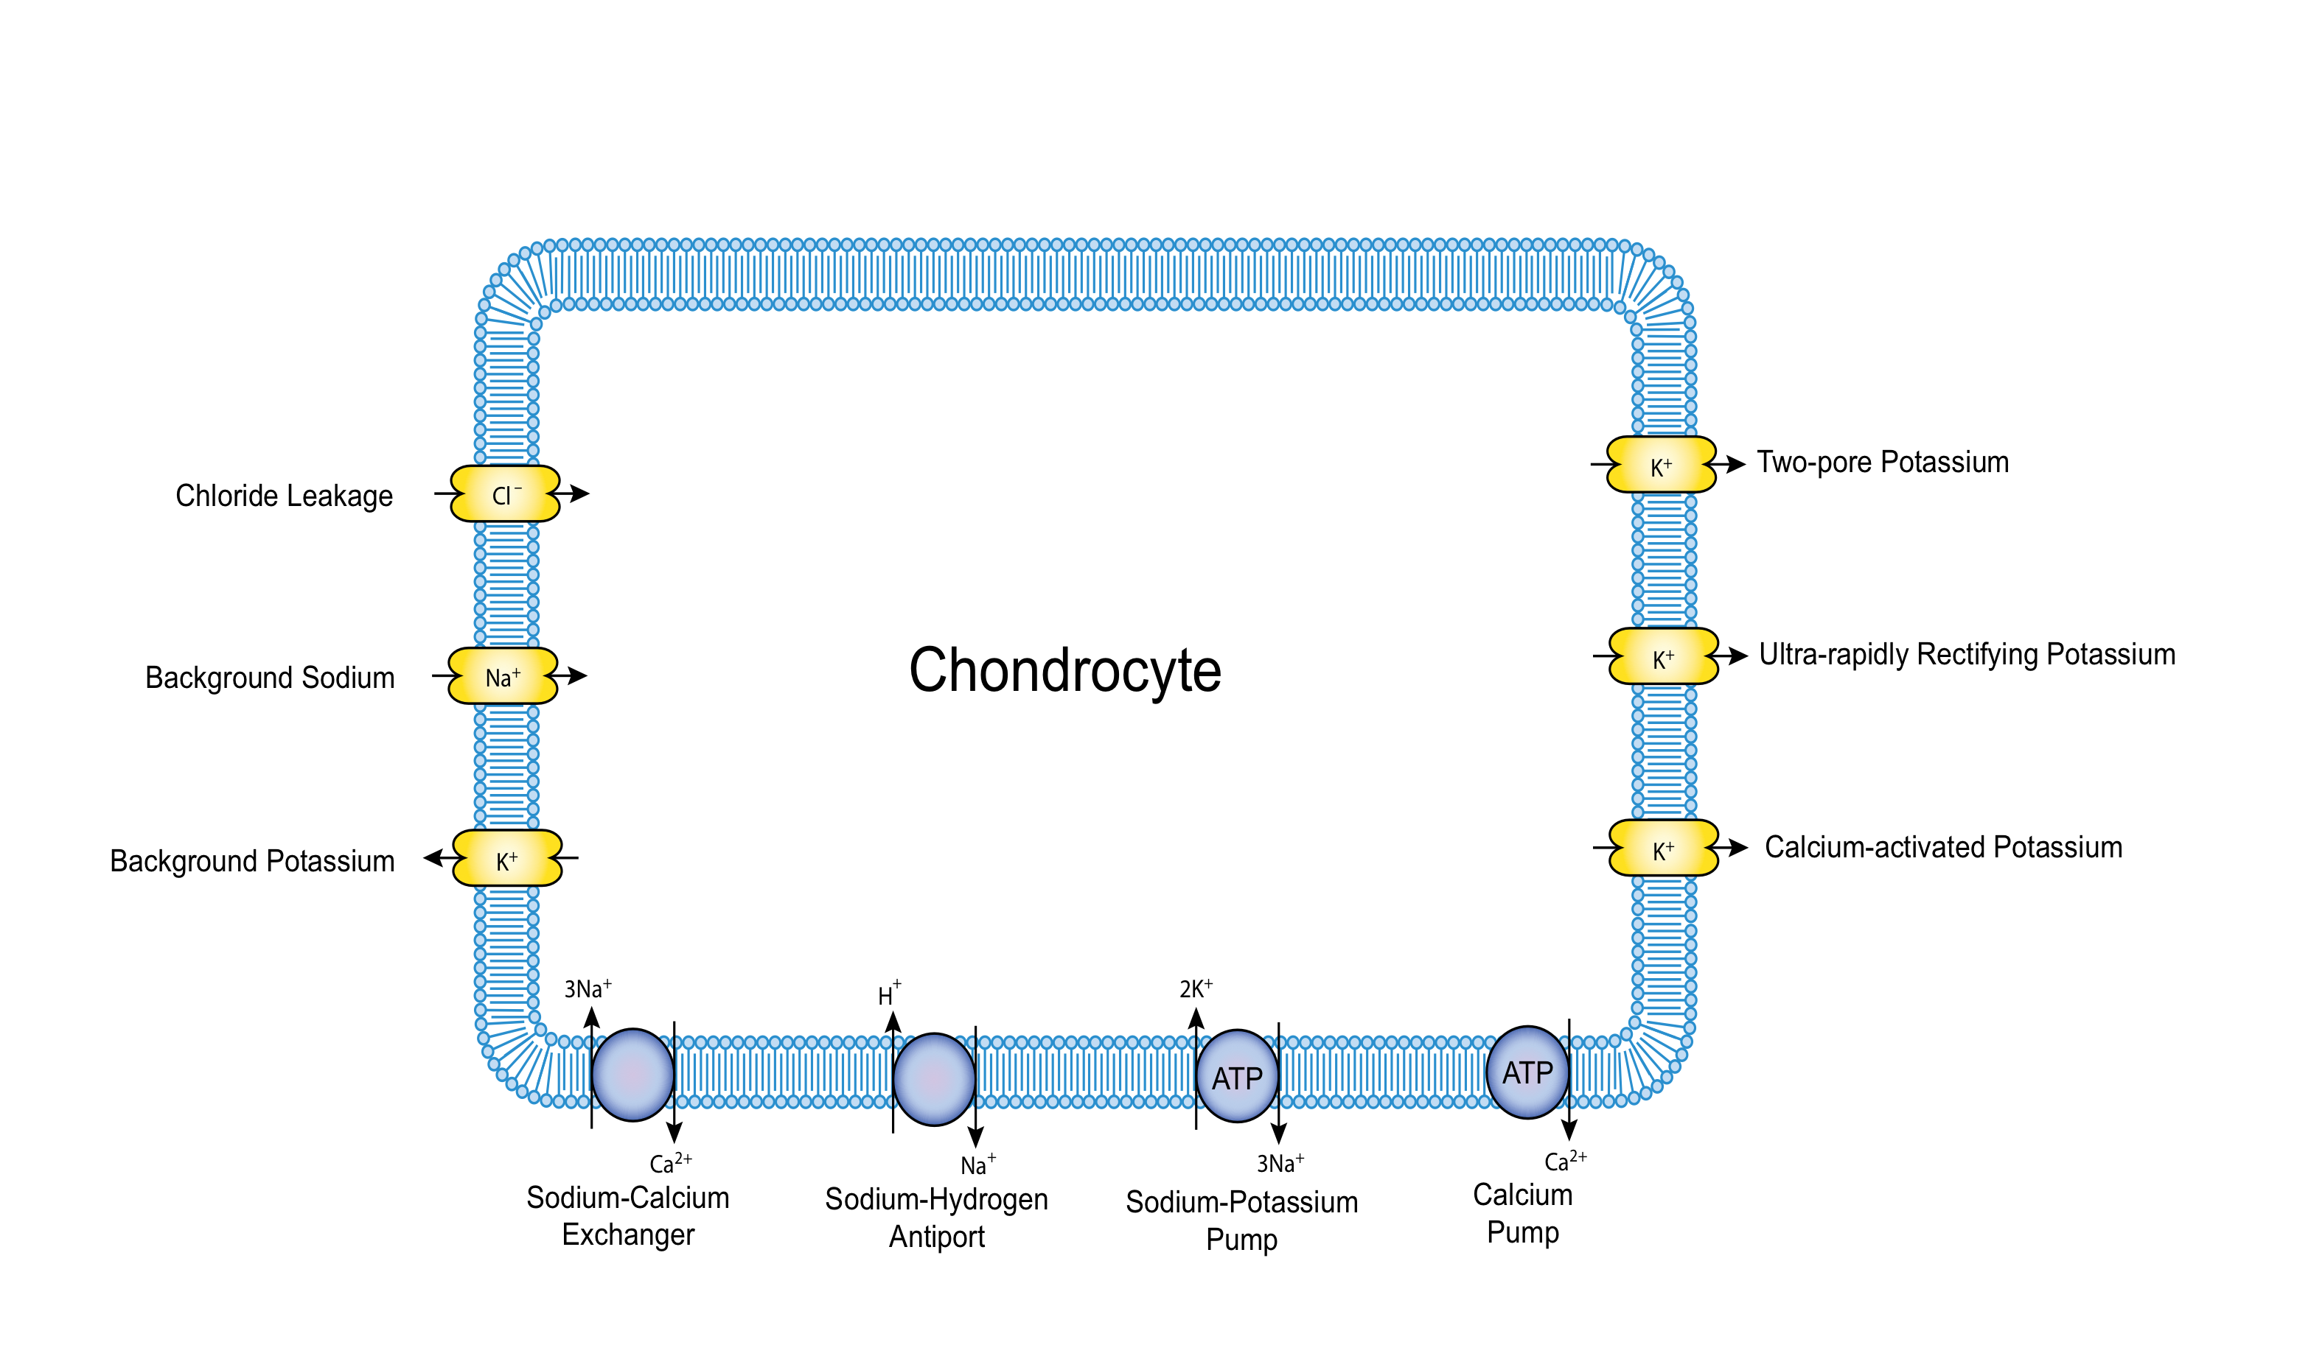**Figure 2**

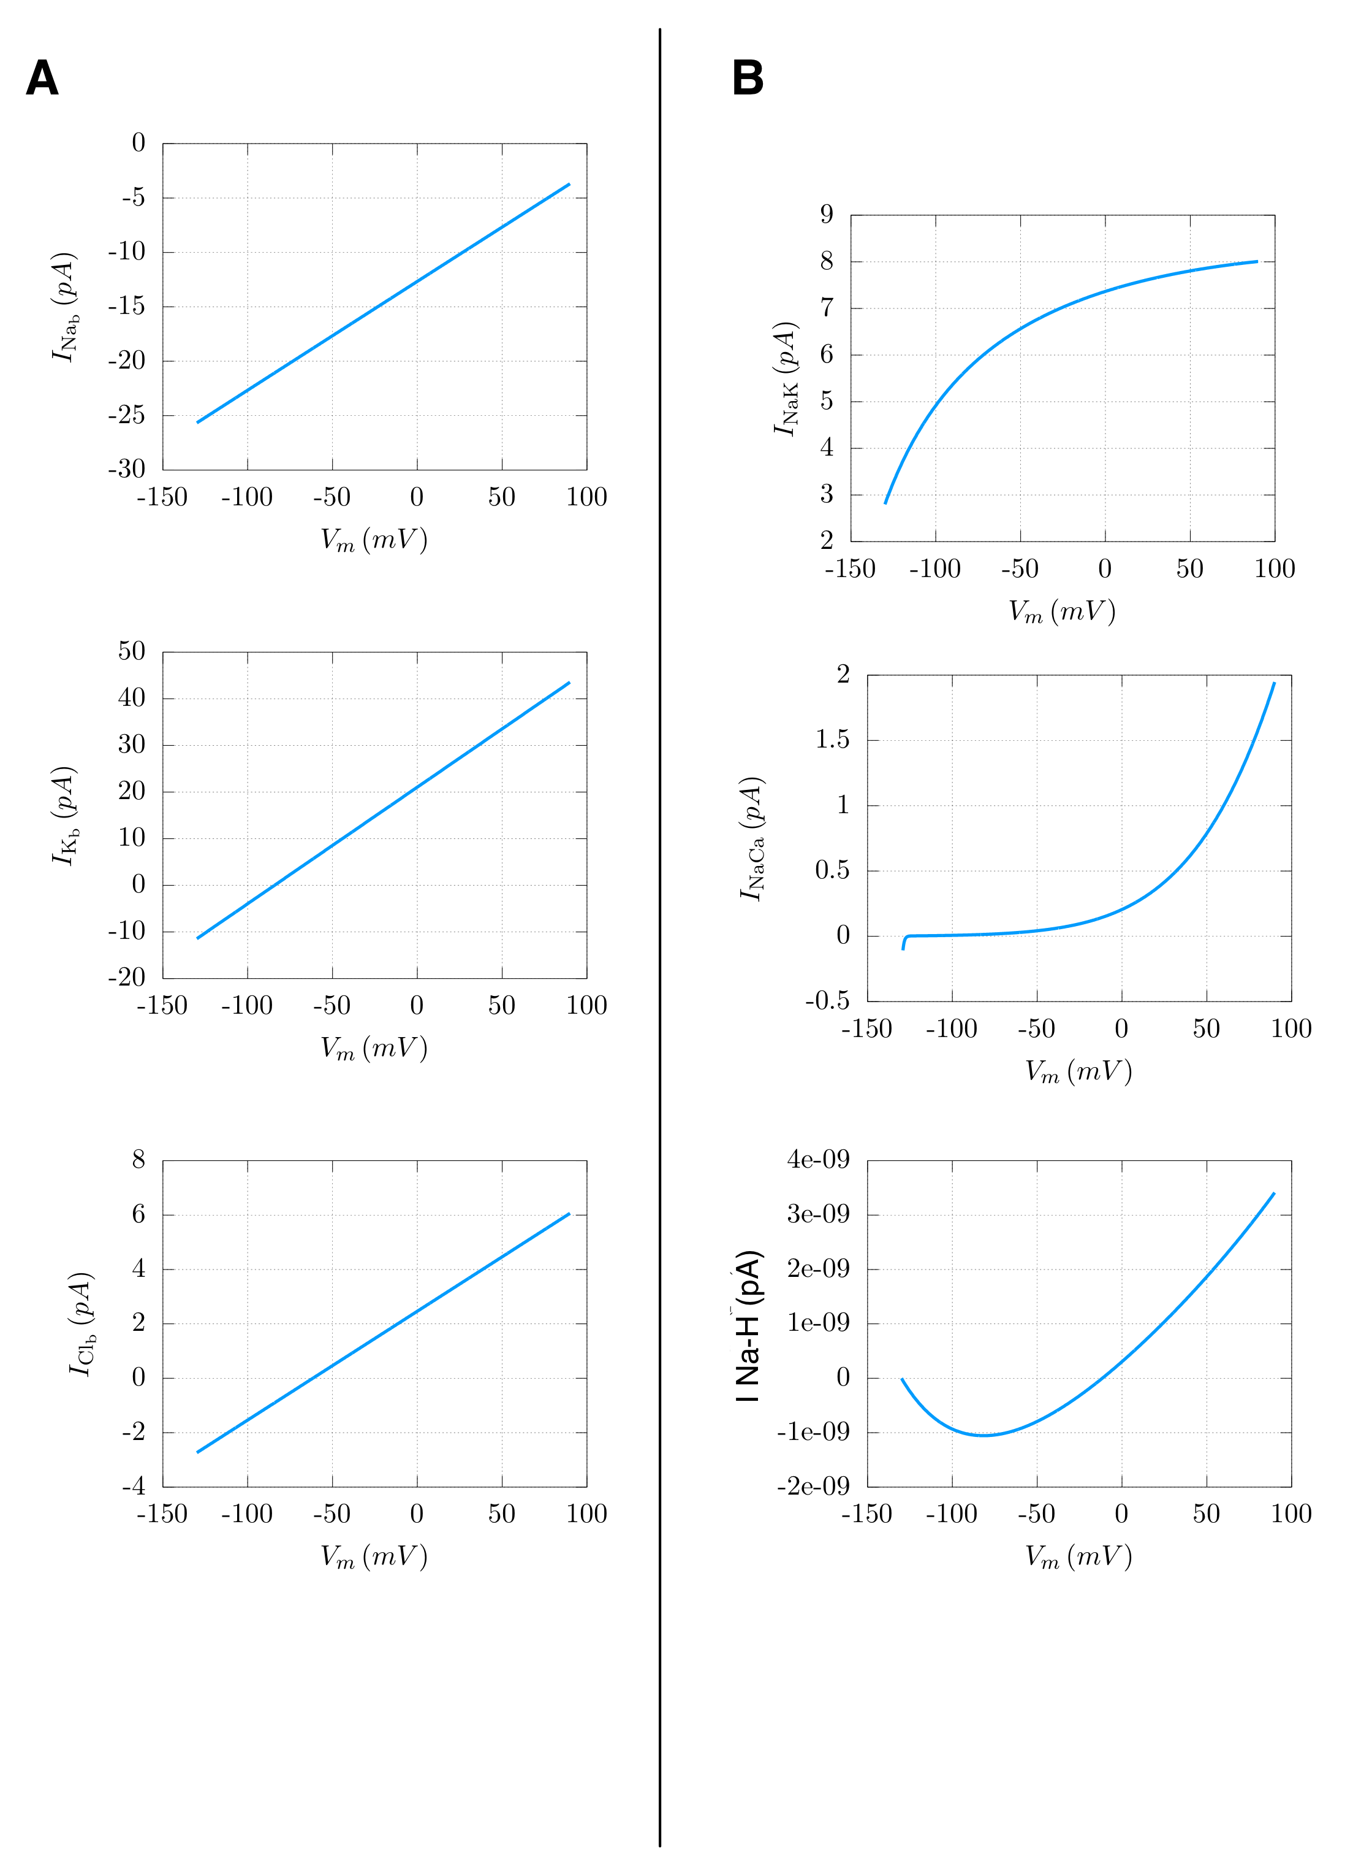

**Figure 3**

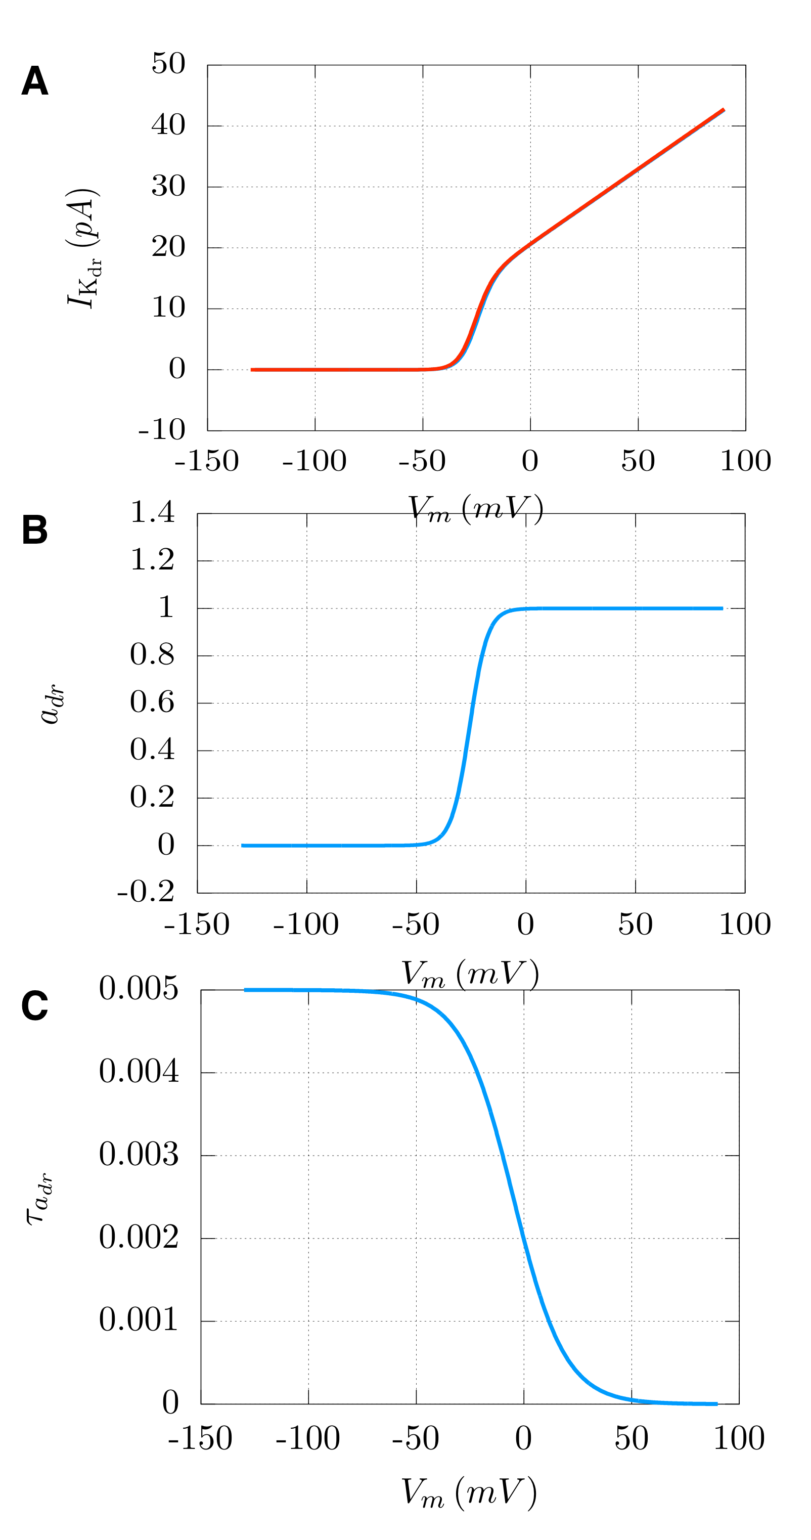

**Figure 4**

Experimental figure to be included.

**Figure 5**

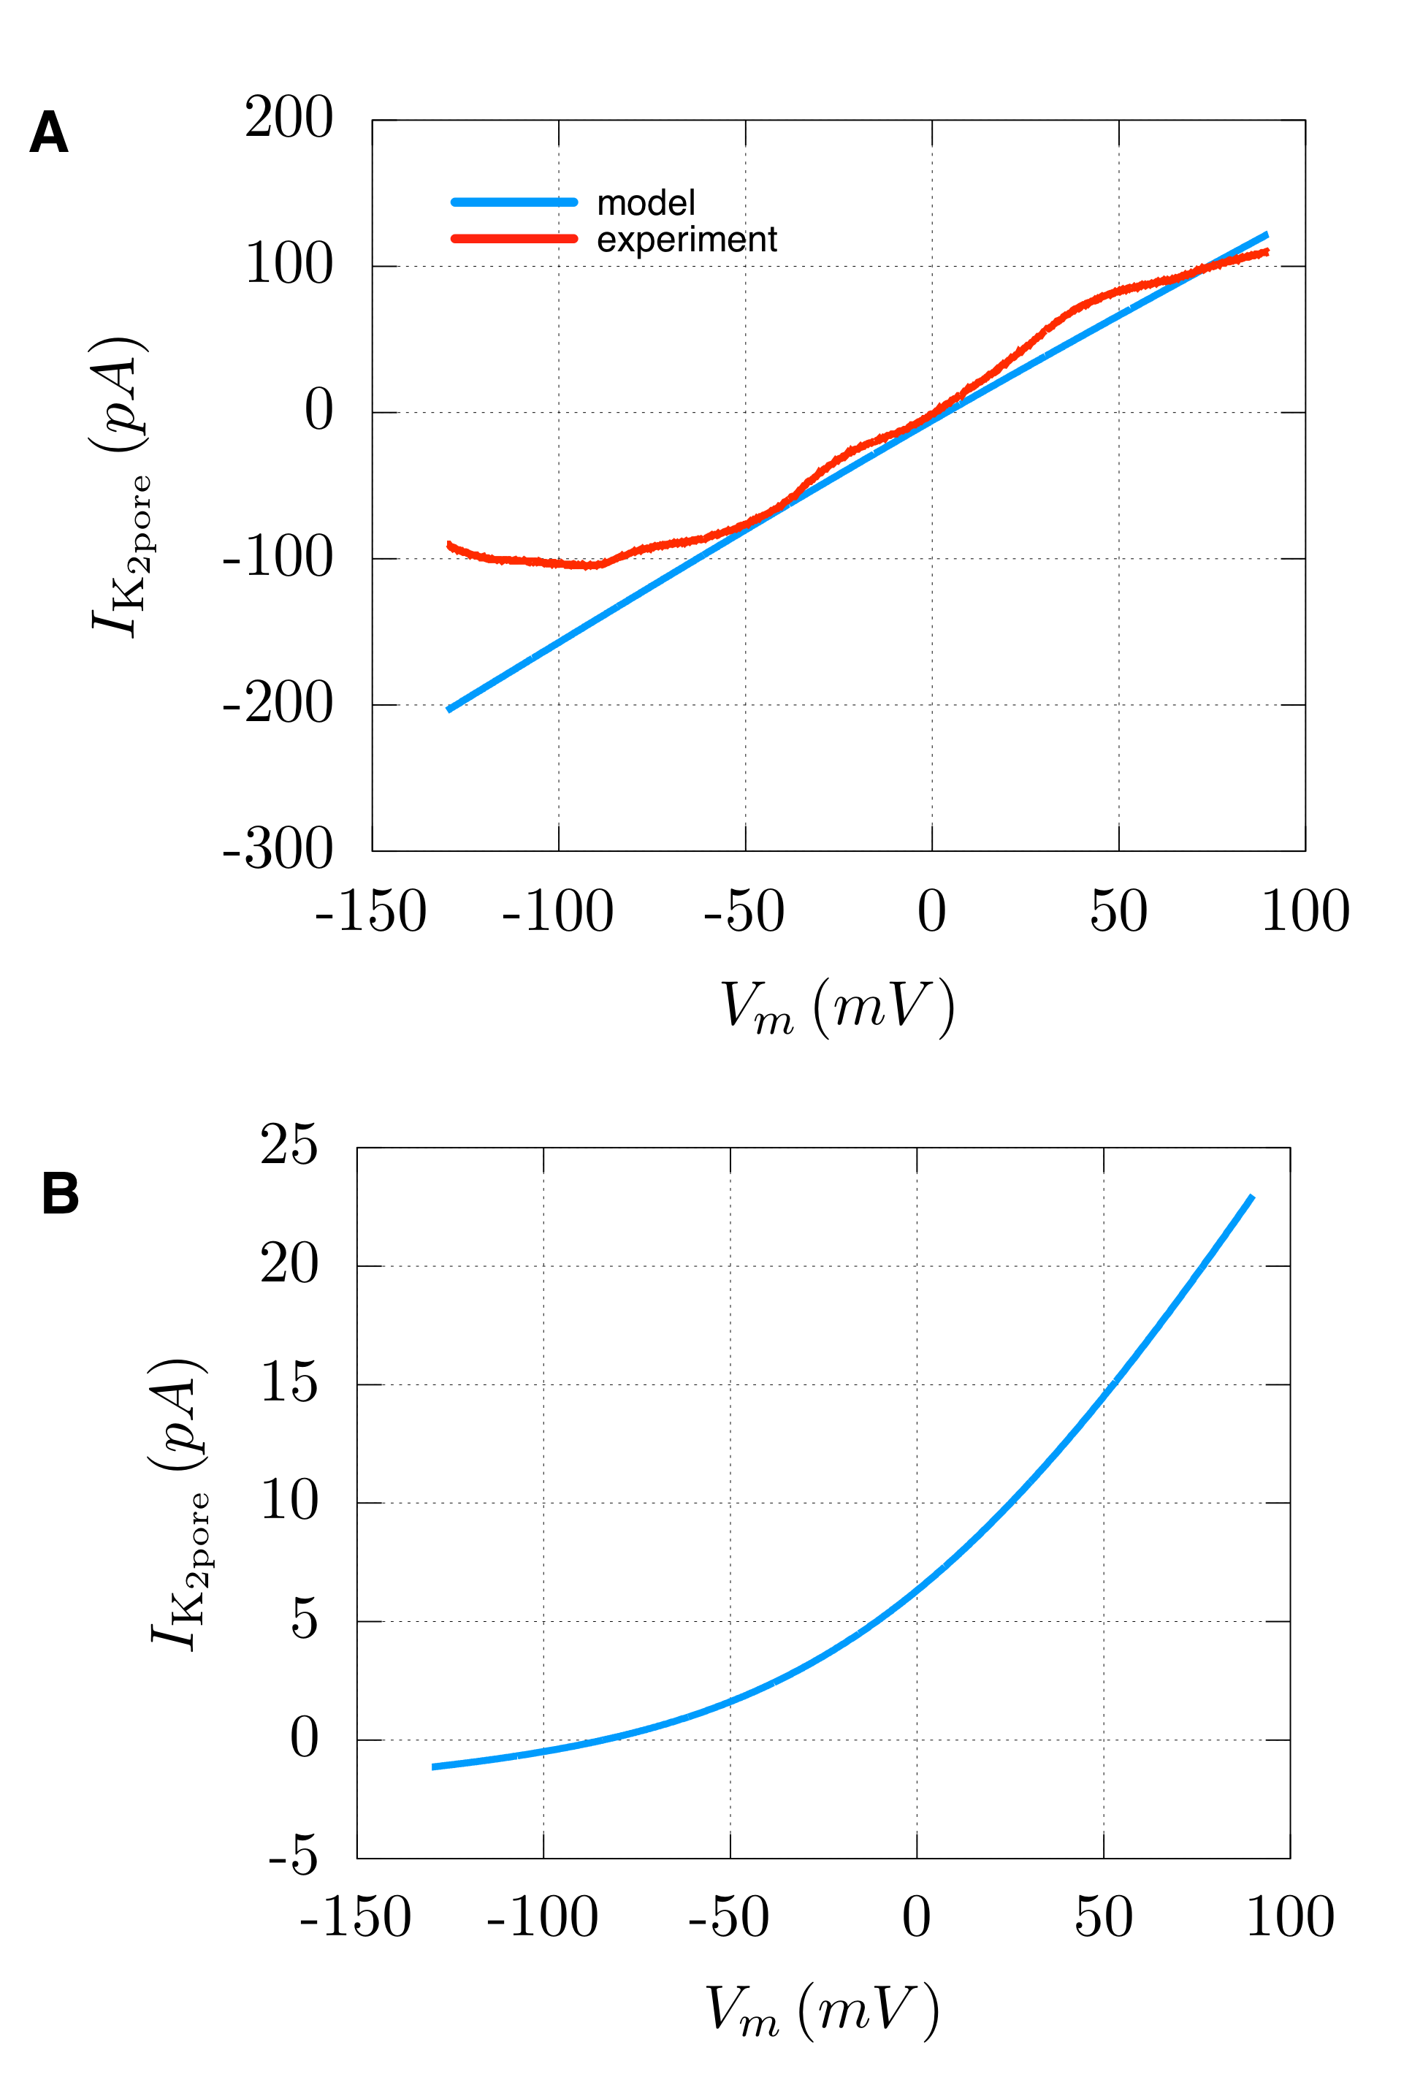

**Figure 6**

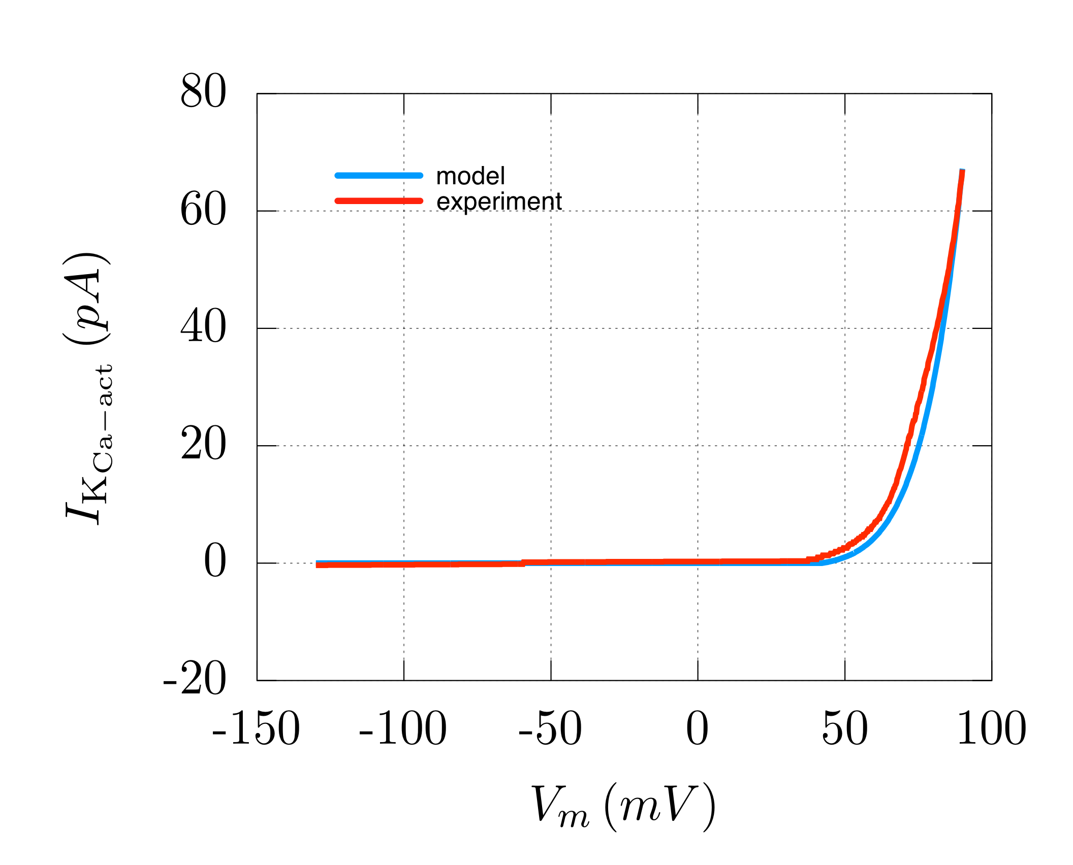

**Figure 7**

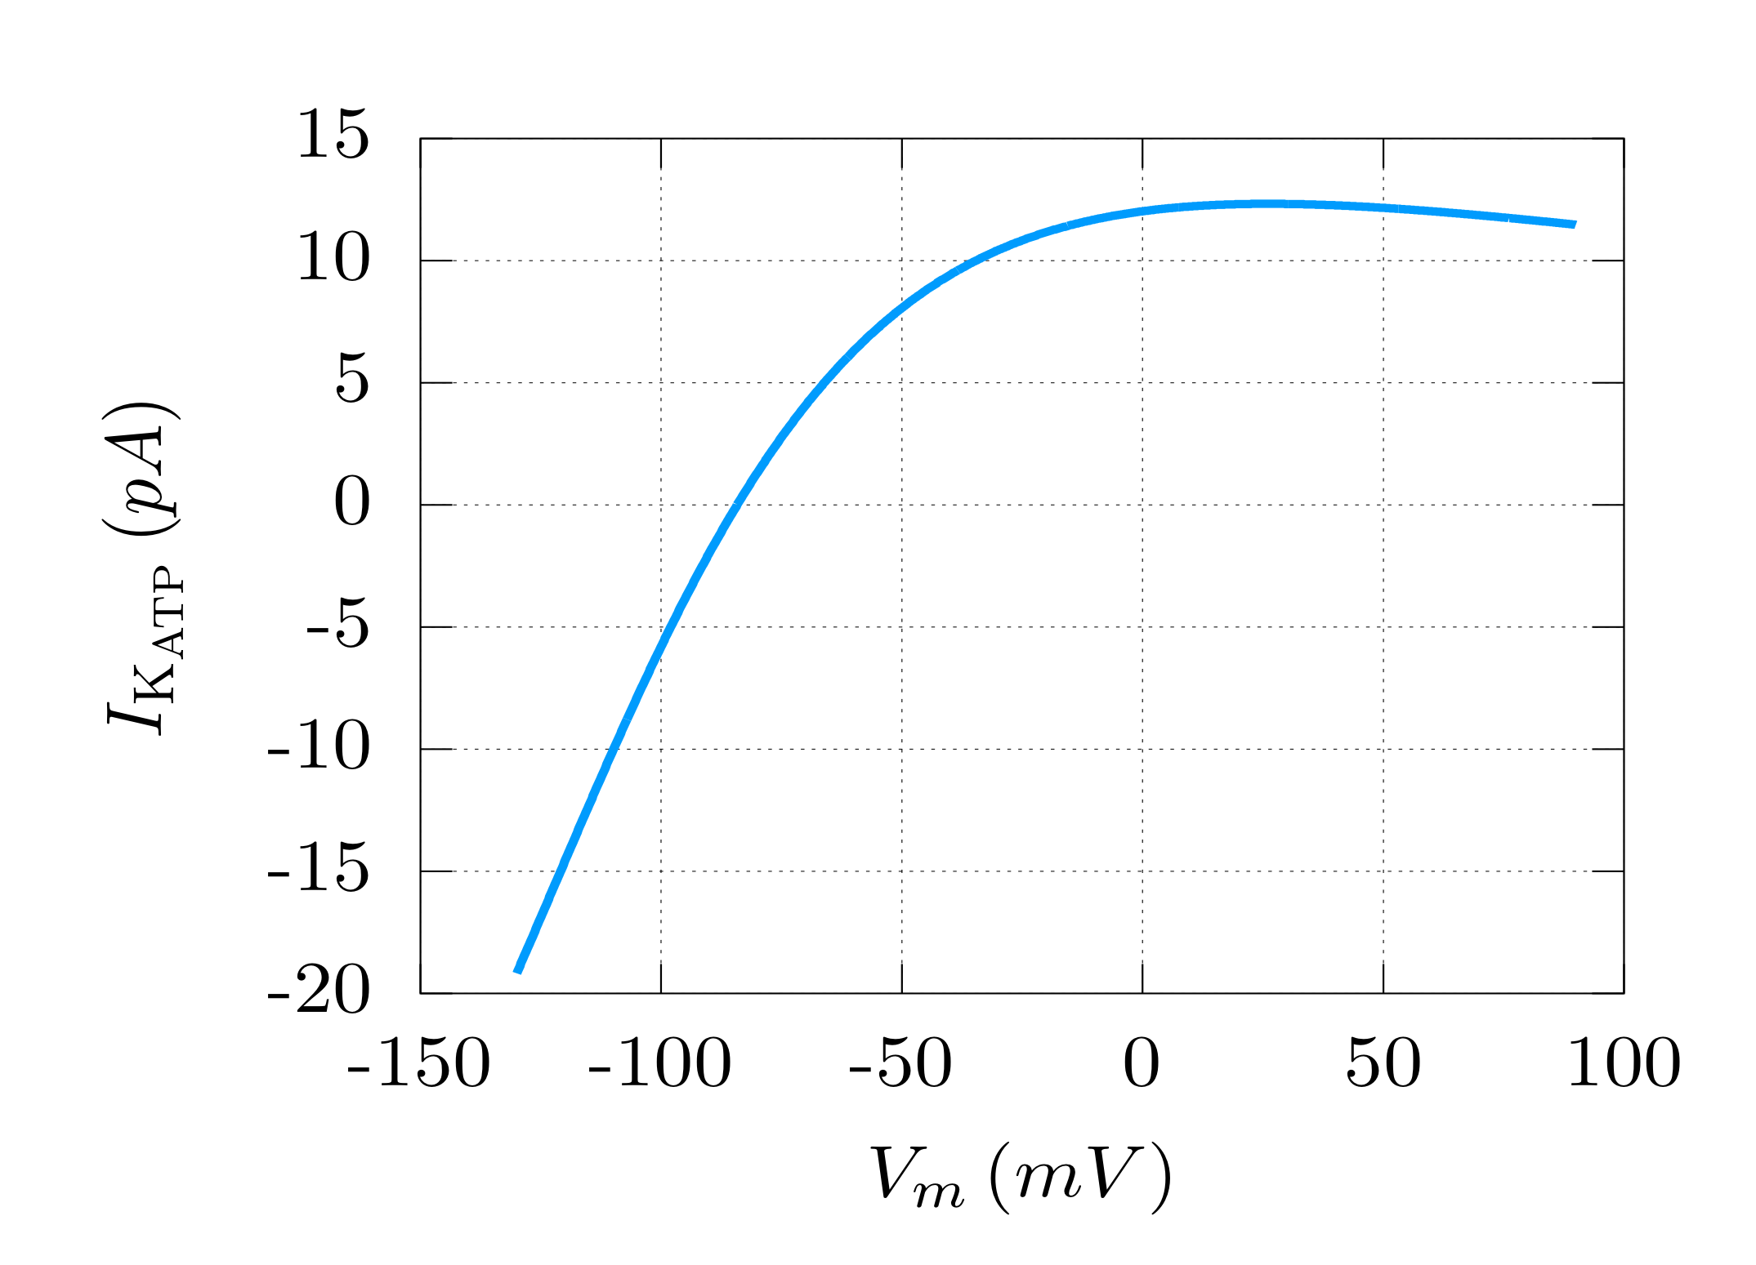

**Figure 8**

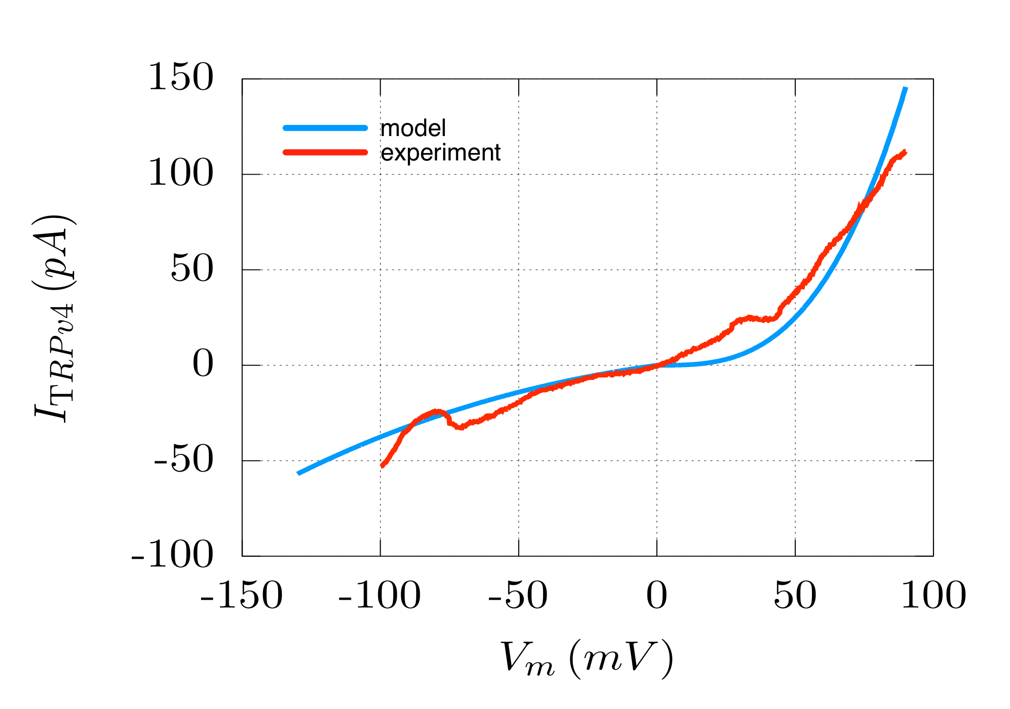

**Figure 9**

APPENDIX:

Model of seal resistance re: membrane potential